**Dense Spatial Time Series Estimation of Groundwater Overexploitation by High Intensity Agriculture**

Tristan Grupp1

1 Department of City and Regional Planning, University of Pennsylvania, Philadelphia, USA

E-mail: [tristan.grupp@mail.mcgill.ca](mailto:tristan.grupp@mail.mcgill.ca)

Abstract

The overexploitation of groundwater resources is a major sustainability challenge. In arid regions, where limited rainfall is unable to rapidly replenish unconfined aquifers and non-renewing confined aquifers are tapped, water users compete for scarce resources. This study investigates the over-use of groundwater in Ica, Peru. This dry region heavily relies upon groundwater to support high intensity agriculture. The use of groundwater is often unmonitored with traditional water metering. To address this challenge, this study uses a dense time series of Landsat-8 and Sentinel-2 imagery from 2019 to 2021 to find the persistence and breakpoints of NDVI (normalized difference vegetation index) over course of each year at the field level. The persistence of NDVI and the number of breakpoints informs a risk analysis of groundwater over-pumping. This study provides a methodology for water monitoring in arid regions.

Keywords: agricultural intensity, groundwater, water scarcity, arid, remote sensing, image segmentation, time series, breakpoint detection

1. Introduction

Water resources in arid regions must be judicously managed. Without reliable access to surface water, arid regions depend upon groundwater reosurces to meet water demand. Much of this water demand comes from agricultural users in arid regions. These arid regions can be desiriable for cultivation due to the high amount of sunshine and long or year-round growing season. Studying the impact of agriculture on water resources is essential for water management because, globally, agriculture “accounts for more than 70% of global freshwater withdrawals”1. In some developing countries, agriculture can use up to 95% of local freshwater resources1. Further, the water for 40% of the irrigated surface of the earth is provided by groundwater resources1. This number increases in regions with limited rainfall and surface waters. For arid regions, groundwater management among agricultural users is a critical water planning and sustainability challenge.

Water resources used in agriculture include surface water, precipitation, unconfined aquifer withdrawal, and confined aquifer withdrawal. Surface and aquifer water can be brought to an area by canals, pipes and irrigation infrastructure. Because groundwater volume and uptake is harder to estimate and in many countries is not given the same legal protections as surface water, groundwater often can be over-exploited compared to other sources2. Estimating the intensity of groundwater use by agriculture is important in the identification of sections of an aquifer that may be at risk for exhaustion and to hold accountable agricultural users that use groundwater unsustainably.

1.1 Ica Background

Ica is a city on coast of Peru, on the western side of the Andes Mountains. Ica is 300 kilometers south from the capital of Lima and has a population of 282,0003. It is classified as a hyperarid region that receives less than 10 mm/a in rainfall3. The city contains two groundwater systems; the Ica Valley Aquifer and the Villacurí Aquifer3. The Ica river flows through the Ica Valley Aquifer and is fed by mountain rainfall. Some subsurface water from the Ica river flows into the Villacurí, however, it is limited and depends upon the level of the river3. Often in the driest months, the Ica river will have no flow5. In some years, Ica receives no rainfall and the river will carry little to no water5.

Extracting Climate Hazards Group InfraRed Precipitation with Station data (CHIRPS) to the Hydroshed basins of the Ica and Villacurí basins reveals that, in a three year average window of precipitation (2018-2020), the Ica Valley basin received 5.5 times the amount of rainfall as the Villacurí despite being only four times larger. The Ica Valley also has a substantially larger mountain watershed that captures a significant amount of rainfall which creates the Ica river. The Villacurí mountain area is much smaller. There are no permanent streams or rivers within the Villacurí basin. The level of precipitation is so limited within the basin that surface waters are not present. Due to the limited inflows, the Villacurí basin is replenished far more slowly and is at greater risk of over-exploitation. Villacurí aquifer is “an effectively non-renewable groundwater source”6.

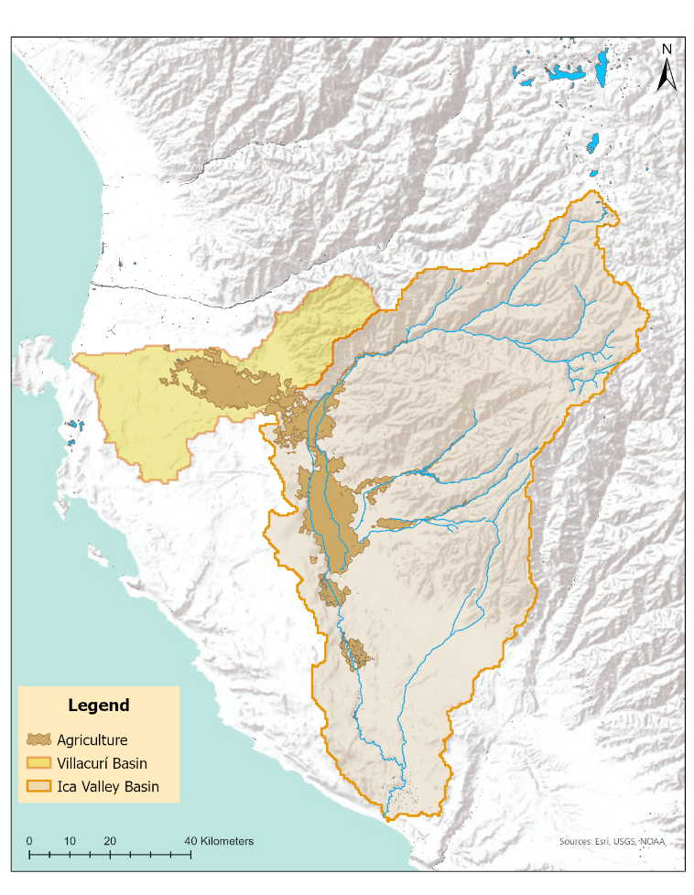

Figure 1: The hydrogeographic setting of Ica, Peru

Overabstraction for agriculture is the greatest threat to the aquifers and the water security of the region. In 2016, the Ica Valley aquifer was exploited at 76% over the sustainable yield and 262% over the sustainable yield for the Villacurí aquifer6. Between 1998 and 2011, the water table fell 1.4 meters in the Ica Valley aquifer and fell 1.5 meters per year in the Villacurí aquifer6. The combined “Ica-Villacurí Aquifer is the most exploited aquifer in Peru” and whose water table has fallen from “30 meters to 180 meters below ground level”in the last 30 years17.

Agriculture dominates Ica’s water, employing 40% of the population to produce asparagus, artichokes, avocados, mangos, and red globe grapes16. These agricultural firms are typically very large and require deep wells to tap into the aquifers to produce these crops. While these firms employ a substantial part of the population, they control the bulk of water extracted from the Ica region. Manyagricultural producers use groundwater every hour of the day, citizens lack regular water access; “[h]omes currently have access to drinking water every two days and for less than four hours”15. There is a tension between the needs of Ica residents and the water demand of agro-export firms to maintain lush crops in the desert.

1.2 Ica Agricultural Background

The rise of agroindustries in the Ica Valley since the 1990s has been the main driver of groundwater over-abstraction5. The Peruvian government encouraged large foreign firms to cultivate the desert for high value, water-intensive cash crops like asparagus and avacado with export-oriented economic policy5. These companies were able to work the arid margins of the desert, far from the surface waters in the Ica River through “borewells and sophisticated irrigaiton technology”5. The Villacurí aquifer requires deeper drilling (30-120 meters) to access water resources than in the Ica Valley Aquifer (3-40 meters)3. Because of the difficulty of accessing deep water resources, the Villacurí aquifer is used exclusively for crop irrigation by large agroexport firms that can afford to construct and deep wells and pumps7.

1.2.1 Ica Agricultural Background – Land Tenure

The Peruvian national government viewed small family farms in the region as “inefficient in producing for a global market requiring high-quality, massive volume, and constant production”7. Attempting to expand its export economy, the government fostered large companies through market-oriented policies such as “including the privatization of land to promote a modern agro-export sector through large land extensions”13. Between 1994 and 2012, medium size land ownership (100-500 hectare plots) increased by 20% while large land ownership (>500 hectare plots) increased by 348%7. The government encouraged high value crops like grapes and asparagus to meet “increased worldwide demand for fresh crop luxury foods”7. These crops became particularly valuable in the off-season when Ica could produce those crops given the favorable growing climate and soil conditions13. The international demand for luxury crops and government support enabled the growth of these large agro-export firms in Ica.

The majority of farmers in the Ica Valley are small farmers with less than 3 hectares12. 68% of the total number of farmers are small holders who own only 12.3% of the land, whereas large farmers with 50 hectares or more represent 0.5% of the farmers but own 14% of the land12. It is estimated that there are more than 15,600 small-scale farmers in a harvest area of around 10,000 hectares, whereas 200 companies occupy over 17,000 hectares or 63% of total harvest land10. Large companies dominate the growth area in the Ica region and own the lionshare of the land. The shift from small cultivation to large scale cultivation is clear and has important implications for the use of water resources.

1.2.2 Ica Agricultural Background – Water Management

Water uses in the valley exclusively abstracting groundwater represent only 0.1 percent of the total number of irrigators14. Despite their low numbers, these large-scale land owners users own hundred of wells for groundwater extraction. May of these wells are unmonitored. The state allowed 114.3 mm^3 of groundwater extraction in 201114. A 2009 estimate placed the actual groundwater use volume at three times this numner; 334 mm^314.

There was no formal regulation of groundwater use before 20097. A new water resources law – the 2009 National Water Law and its implementing regulations – was enacted in 2009 requiring that land owners obtain a water concession permit for any groundwater extracted under their property17, 7. The water concession permit specifies an amount of water that can be extracted in a year. The permit laws, however, are poorly enforced. In Ica, there are an estimated 860 groundwater wells “of which only 249 have a license”7,8. The Ica agribuisnesses association “fiercely opposes” representatives of the Autoridad Nacional del Agua (ANA, even “physically prevent[ing]” government officials from entering their properties to check on well water usage7. Because the government has a vested interest in the success of these businesses for export taxes and regional employment, the ANA has allowed well owners to self-report water usage, “in effect giving agro-export companies the right to self-regulate”7. Despite government efforts to formalize wells after an emergency drought declaration in 2011, by 2015, only about 35% of wells in Villacurí had any form of a license7.

Other water management failures include the government’s policy of allowing firms with a certificate of water efficency to build new wells14. Large scale firms are the essentially the only users that can install infrastructure such as drip irrigation systems to benefit from this policy. “The lengthy administrative process to obtain new permits and drill new wells benefits larger farmers with the financial means to employ lawyers to carry out the paperwork and rent equipment to drill new wells”14. Because large agro-industrial firms use the majority of underground water resources, this policy is concerning. The scale and operation of these larger firms deplete the aquifers more quickly than small operations who cultivate for only part of the year, plant less water intensive crops, and engage in irrigation methods that can recharge the aquifer, such as using indigenous infiltration ponds known as *pozas*5. Further, the growth of these large firms has occurred mainly on the desert fringes, far from surface waters. 72% of the expansion of large-scale farms since the 1990s has taken place on former deserts which can only be irrigated from groundwater4. This policy encourages the expansion of agriculture onto deserts that must be supplied with groundwater.

Another water management failure is the housing of the ANA under the Ministry of Agriculture which subjects the country’s water regulator to agroindustry interests6. Finally, In the Ica Valley, large scale users can purchase permits from small farmers and use aqueducts and canals to move those water resources from small farms to larger operations6. A notable instance of the purchasing of water concession permits for use in another area is of “a 580-hectare farm with an allocated abstraction volume of 0.5 million cubic meters per year via three official permits, but which actually owns 20 wells and is pumping 9.3 million cubic meters per year.”14 The management of water resources in Peru is poor and unsustainable.

Figure 2 shows the location of surface water storage sites used to house pumped aquifer water. Surface water storage sites were identified using European Commission's Joint Research Centre’s water layers pulled from Google Earth Engine. Water locations were found using the maximum water extent dataset from JRC reduced to centroid points. The dataset was cleaned and the centroids were inspected before creating the final surface water storage dataset. Additional points were identified with visual inspection using ArcGIS’s imagery basemap. The scale of agricultural operations was added to Figure 2 from Salmoral et al. 2020. The vast majority of surface water storage sites fall within Salmoral et al. 2020’s large scale agricultural areas. The use of groundwater is almost entirely by large agroindustrial firms for export. Determining the water use within large scale farms that are far from the Ica river’s surface waters will help identify those that are pumping the greatest amount of water from the two aquifers.

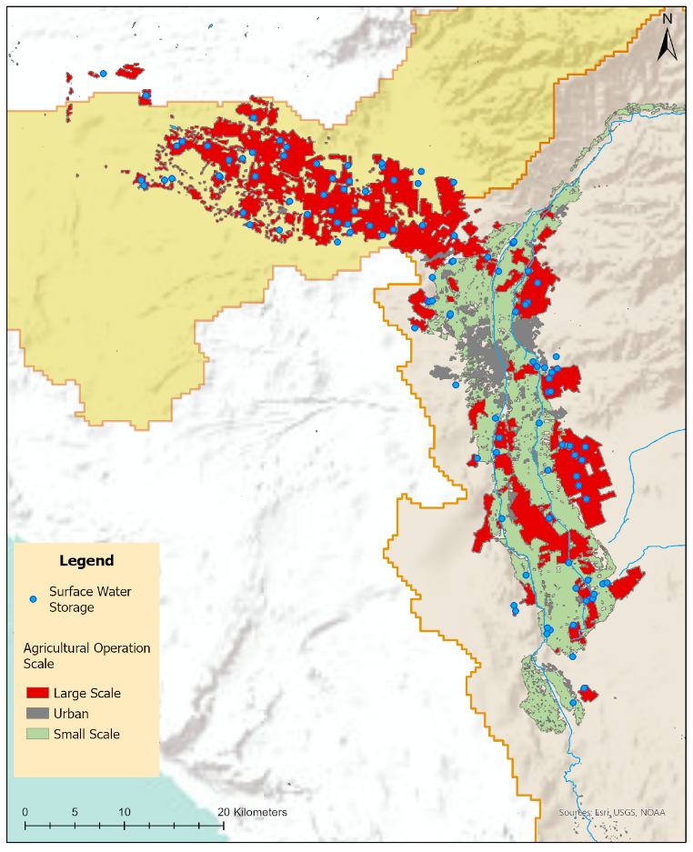

Figure 2: the location of water pumps visible from satellite imagery and the scale of agricultural operations. The extent of agricultural operations is taken from Salmoral et al. 2020.

2. Methods

By segmenting a stack of normalized difference vegetation index (NDVI) images that capture the stages of crops at different times of year, this study attempts to isolate individual fields and determine their land use trajectories and use intensity. The use intensity of each field can inform an estimation of water use. Estimating how much water is used in each field will help identify areas of both of the aquifers most impacted by agroindustry overabstraction. This may help water monitors focus their efforts and crackdown on overpumping. The segmentation and land use intensity methodology draws upon Dutrieux et al.’s 2016 study of crop cycles within swidden agricultural fields in the Brazilian Amazon18. This method of breakpoint detection in segemented polygons to count agricultural cycles with a dense time series has not yet been applied to estimations of water use in agriculture, nor in studies of arid agriculture.

2.1 NDVI Image Acquisition

This study acquired and processed Landsat-8 and Sentinel-2 imagery in Google Earth Engine (GEE). Two scripts were written to pull together image collections from both sensors within two week periods from 2019 to 2021. The revisit time of Landsat 8 is sixteen days and therefore a two week period would only capture one image per image tile. Sentinel-2 revists every ten days from the same viewing angle. A two week period can capture up to two images within the image collection over the same area. The scripts mask clouds, cloud shadows, and water within all images in the image collection, calculate NDVI, and take their maximum values in order to reduce the image collection to a single mosaic. NDVI is a well established index of vegetation health often used in agricultural applications19. NDVI is the ratio between the red (R) and near infrared (NIR) of the two sensors:



This method reduces the amount of no data by taking the maximum NDVI values of overlapping images within the collection. All two week mosaics for both sensors, regardless of the amount of missing data, were exported from GEE for 2019-2021.

2.2 Image Stack Segmentation

This study segments fields following the Dutrieux et al. 2016 methodology. This study maintains a multi-temporal image segmentation over using a mutlispectral image taken in one year. There are multiple land use trajectories, especially within the agriculture bordering the Ica River and temporary streams, that would justify using multi-temporal image segmentation over a single, multispectral image18. These surface water dependant fields change significantly over the course of year depending on rain conditions and flow rates within the river. Drought conditions cause fields to left idle for significant stretches of time. A single multispectral image would fail to capture surface water dependant fields experiencing drought. Therefore, a multitemporal segmentation method is used in this study.

This segmentation method “creates clusters of pixels determined by their spectral resemblance and spatial proximity”18. The exported images were sorted to identify those without any cloud cover. Cloud cover would introduce non-field geometries into the segmentation method and decrease the correct delineation of fields18. The cloud free images were composited into a single image stack in ArcGIS. If too many images were concentrated around a particularly range of months or season, some images were removed to create an even distribution of images over time within the stack. The even temporal distribution allows the method to segment based upon vegetation over the course of the entire year without overrepresentation of a particular crop phenology.

The segmentation method – Large Scale Mean Shift (LSMS) in Orfeo’s OTB toolbox ([www.orfeo-toolbox.org](http://www.orfeo-toolbox.org)) (version 8.0.1) – identifies segments of similar pixels. By using a stack of varying NDVI images over the course of the year, the fields were segmented according to similar land use trajectories or similar changes in NDVI18. This segmentation method creates polygons around pixel values that contain similar values within the stack18. Pixels within the same field change similarly and are therefore segmented together. A field pixel radius, or “range radius, which is the similarity (Euclidean distance) measure for a pair of pixel profiles”, of 0.14 was used18.

The segmentation was applied to the entire image. To isolate fields, only fields with NDVI values above 0.3 in at least three of the images used to implement the segmentation were kept. All other fields were removed. Fields within the Salmoral et al. 2020 urban area extent were also removed. The segmentation result can be seen in the appendix.

2.3 Sensor Combination

Using the exact-extractr package in R, NDVI values were extracted to the segmented field polygons. The mean values of all pixels within each geometry were assigned to each field polygon. Two dataframes were created for both sensors. The Sentinel-2 dataframe’s missing values were filled in with Landsat 8 NDVI values to create a composite sensor dataframe. Linear interpolation was then applied to reduce nulls values within the composite sensor dataframe. Null values at the end and beginning of the NDVI time series that would not be filled in with linear interpolation took the value of the closest non-null value.

.

3. Results and Discussion

3.1 NDVI Persistence

The persistence of NDVI over the course of the year can help determine crop type and water use intensity. Figure 3 shows a map of the percent of the year that a field had an NDVI value above .4. This value corresponds to sparse vegetation or senescing crops20. In this arid environment, the maintenance of sparse vegetation requires water input. Values above .4 indicate that the field has been irrigated.

For each field and for each time period, the NDVI value was reclassified to 1 or 0 by whether or not it exceeded a NDVI value of .4. These were summed and used to create the percent measure. Figure 4 highlights fields that maintained an NDVI above .4 for more than 90% of the year and were greater than 1.5 kilometers from the nearest surface water. These fields require high amounts of irrigation in order to maintain the vegetation in the desert. The fields highlighted in figure 4 are also far from surface water, implying that the irrigation for these fields was supplied by groundwater. These fields are of particular interest for groundwater monitoring.

The persistence of NDVI over the course of year may help identify woody crops that require constant irrigaton such as grape vines, avacado trees, treenuts and jojoba. The identification of crop type can help improve water use estimations.

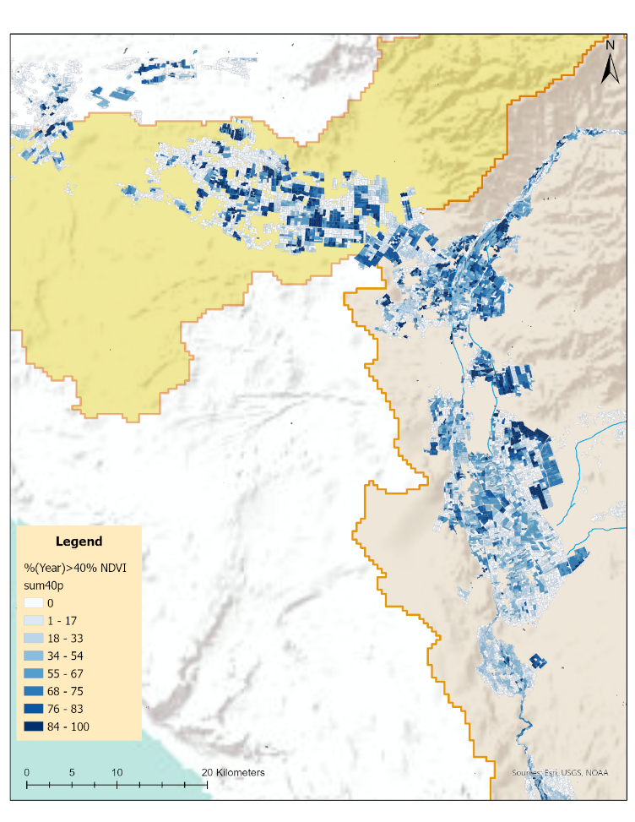

Figure 3:

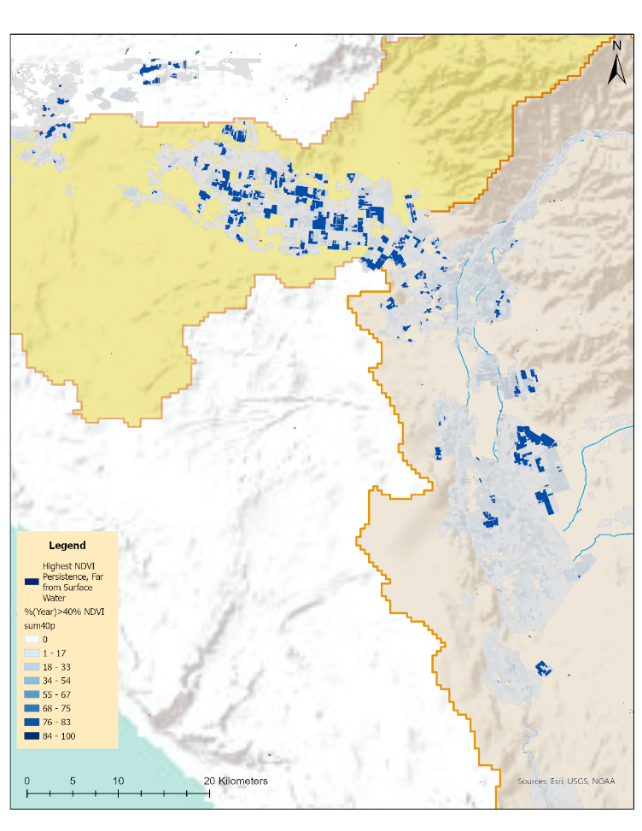

Figure 4:

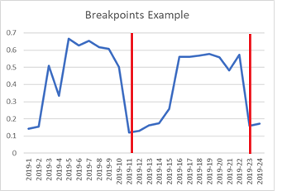

Figure 5: This line graph shows NDVI over the course of 2019 for a field within a large-scale operation. There are two clear breakpoints, implying that the field was cropped and harvested twice.

3.2 Breakpoint Detection and Crop Cycles

Breakpoint detection allows for the identification of crop cycles within each field. In the valley, large firms will produce crops multiple times a year7. Cropping multiple times a year is water intensive. Determining the number of croppings for non-persistant vegetation fields will improve upon the estimation of groundwater use and risk analysis of over abstraction.

4. Conclusion

Sustainability problems require strong measurement. Strong, accurate measurement empowers the city to identify the most problematic water users, use that information to push for change, model how much water is used, come up with a plan, and evaluate how it is performing. The methodology presented in this paper provides a detailed estimation of agricultural intensity. Agricultural intensity metrics at the field level can empower cities to hold individual land owners accountable for water use and estimate which sections of the aquifer may be at greatest risk for over-exploitation.

Acknowledgements

I would like to thank Heather Buleje who introduced me to Ica and its groundwater challenges. I also acknowledge our work in Allison Lassiter’s Water Policy course where we identified Ica’s water portfolio, sources of scarcity, and proposed policy changes to improve management. Thank you to Jonathan Tannen for leading the Advanced Topics in GIS seminar where much of this work was completed.

References

1. FAO (2017). *Water for sustainable food and agriculture: a report produced for the G20 presidency of Germany*. 1-27.
2. Dellapenna, Joseph. (2013). *A Primer on Groundwater Law*. Idaho Law Review. 49.
3. Fernández-Escalante, E., Foster, S., & Navarro-Benegas, R. (2020). *Evolution and sustainability of groundwater use from the ICA aquifers for the most profitable agriculture in Peru*. Hydrogeology Journal, 28(7), 2601–2612. <https://doi.org/10.1007/s10040-020-02203-0>
4. Salmoral, G., Viñarta Carbó, A., Zegarra, E., Knox, J. W., & Rey, D. (2020*). Reconciling irrigation demands for agricultural expansion with environmental sustainability—A preliminary assessment for the Ica Valley, Peru*. Journal of Cleaner Production, 276, 123544. <https://doi.org/10.1016/j.jclepro.2020.123544>
5. Domínguez C., Ore M.T., Verzijl A. (2018). *A short story with some musings on human-groundwater relations along the coast of Peru*. Transformations to Groundwater Sustainability.<https://www.t2sgroundwater.org/narrative-reports-peru>
6. Closas, A., & Molle, F. (2016). *Water Governance in the Americas*. 4th ed., 200-210, Rep. IWMI Project Report.
7. Damonte, Gerardo. (2019). *Hybrid Institutions: Institutionalizing Practices in the Context of Extractive Expansion*. trAndeS. Working Paper Series No. 11
8. Autoridad Nacional del Agua, ANA (2018): *Plan de Gestión del acuífero del valle de Ica y pampas de Villacurí y Lanchas*. <https://www.ana.gob.pe/sites/default/files/normatividad/files/ica_-_plan_de_gestion_0_0.pdf>
9. Salmoral G., Carbó A.V., Zegarra E., Knox J.W., Rey D. (2020). *Reconciling irrigation demands for agricultural expansion with environmental sustainability - A preliminary assessment for the Ica Valley, Peru*. Journal of Cleaner Production, 276. <https://doi.org/10.1016/j.jclepro.2020.123544>
10. Zegarra Méndez, E. (2018). *La gestión del agua desde el punto de vista del Nexo entre el agua, la energía y la alimentación en el Perú: Estudio de caso del valle de Ica*. CEPAL. <https://www.cepal.org/es/publicaciones/44219-la-gestion-agua-punto-vista-nexo-agua-la-energia-la-alimentacion-peru-estudio>
11. Oré, M. T. (2005). *Agua  bien común y usos privados: Riego, estado y conflictos en La Achirana del Inca /* (1. ed.). Pontificia Universidad Católica del Perú, Fondo Editorial: Peru water wars threaten agricultural export boom
12. Scamarone, S.M. (2008) *Estudio socio institucional (ESI) del proyecto de modernizacion de la gestion de recursos hidricos – ES-I PMGRH*, *Cuencas Hidrograficas Chancay – Lambayeque, Ica-Alto Pampas y Chili Quilca*. Instituto Nacional de Recursos Hidricos, Intendencia de Recursos Hidricos, Ministerio de Agricultura.
13. Díaz Rios, L. (2007). *Agro-industries characterization and appraisal: Asparagus in Peru* (Rep.). Rome: FAO, Agricultural Management, Marketing and Finance Service (AGSF) Rural Infrastructure and Agro-Industries Division. <https://www.fao.org/3/ap297e/ap297e.pdf>
14. Cardenas Panduro, A.I. (2012) *'La carrera hacia el fondo'. Acumulacion de agua subterranea por empresas agroexportadoras en el Valle del Ica, Peru*. Msc Thesis, Wageningen University, The Netherlands
15. WSN. (2015). *After the race to the bottom: water supply challenges in the Ica Valley, Peru – International Water Security Network. Water Security Network*. Retrieved May 1, 2022, from <http://www.watersecuritynetwork.org/after-the-race-to-the-bottom-water-supply-challenges-in-the-ica-valley-peru/>
16. Statton, C. (2014). *The Ica Valley: A place of little rain – International Water Security Network*. Water Security Network. Retrieved September 30, 2021, from <http://www.watersecuritynetwork.org/the-ica-valley-a-place-of-little-rain/>
17. OECD (2021). *Water Governance in Peru*. OECD iLibrary, 25 March 2021, [https://www.oecd-ilibrary.org/environment/water-governance-in-peru_568847b5-en. Accessed 12 October 2021](https://www.oecd-ilibrary.org/environment/water-governance-in-peru_568847b5-en.%20Accessed%2012%20October%202021).
18. Dutrieux, L. P., Jakovac, C. C., Latifah, S. H., &amp; Kooistra, L. (2016). *Reconstructing land use history from Landsat Time-Series*. International Journal of Applied Earth Observation and Geoinformation, 47, 112-124. doi:10.1016/j.jag.2015.11.018
19. Tucker, C.J. (1979). *Red and photographic infrared linear combinations for monitoring vegetation*. Remote Sensing of Environment, 8 (2) pp. 127-150
20. USGS. (2018, November 27). NDVI, the Foundation for Remote Sensing Phenology. Retrieved May 1, 2022, from <https://www.usgs.gov/special-topics/remote-sensing-phenology/science/ndvi-foundation-remote-sensing-phenology>

Appendix

Appendix Figure 1

